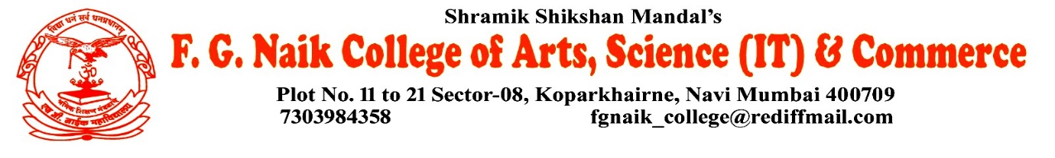

NSS UNIT
HIV/AIDS POSTER MAKING COMPETITION

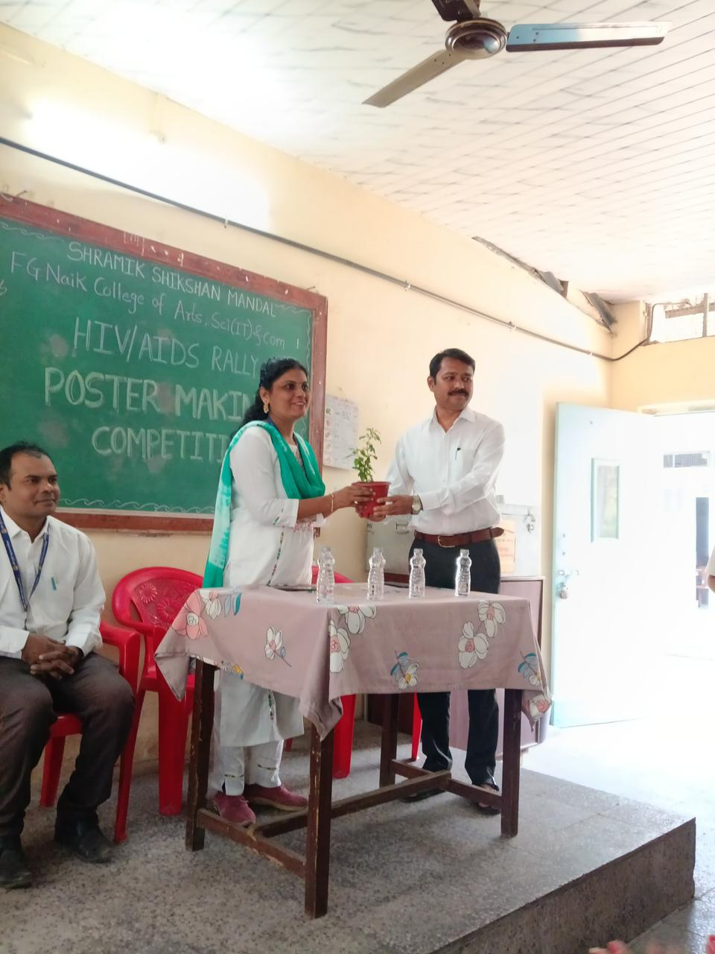
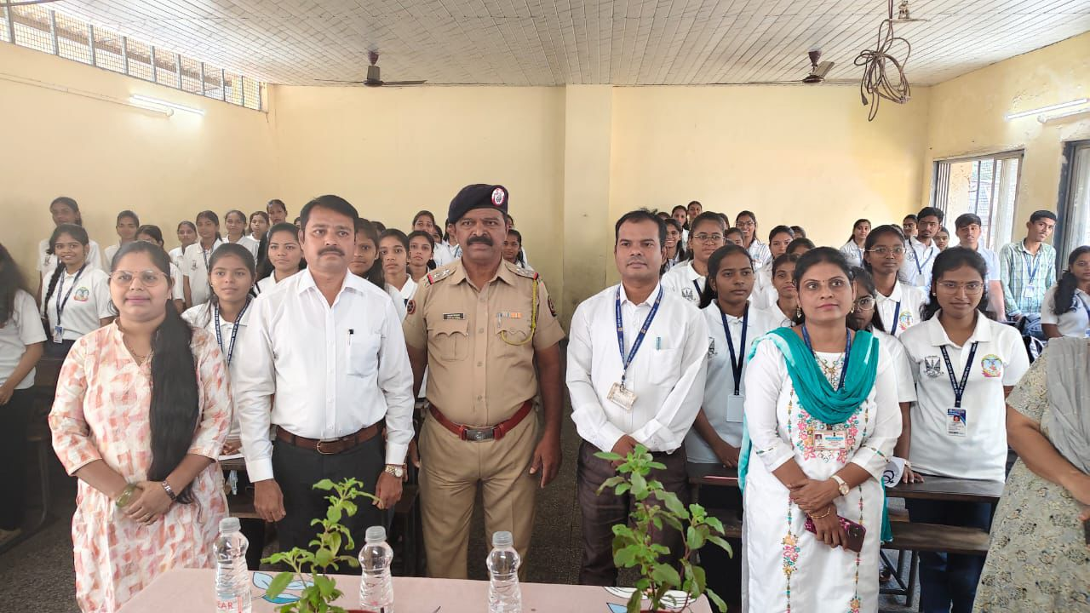

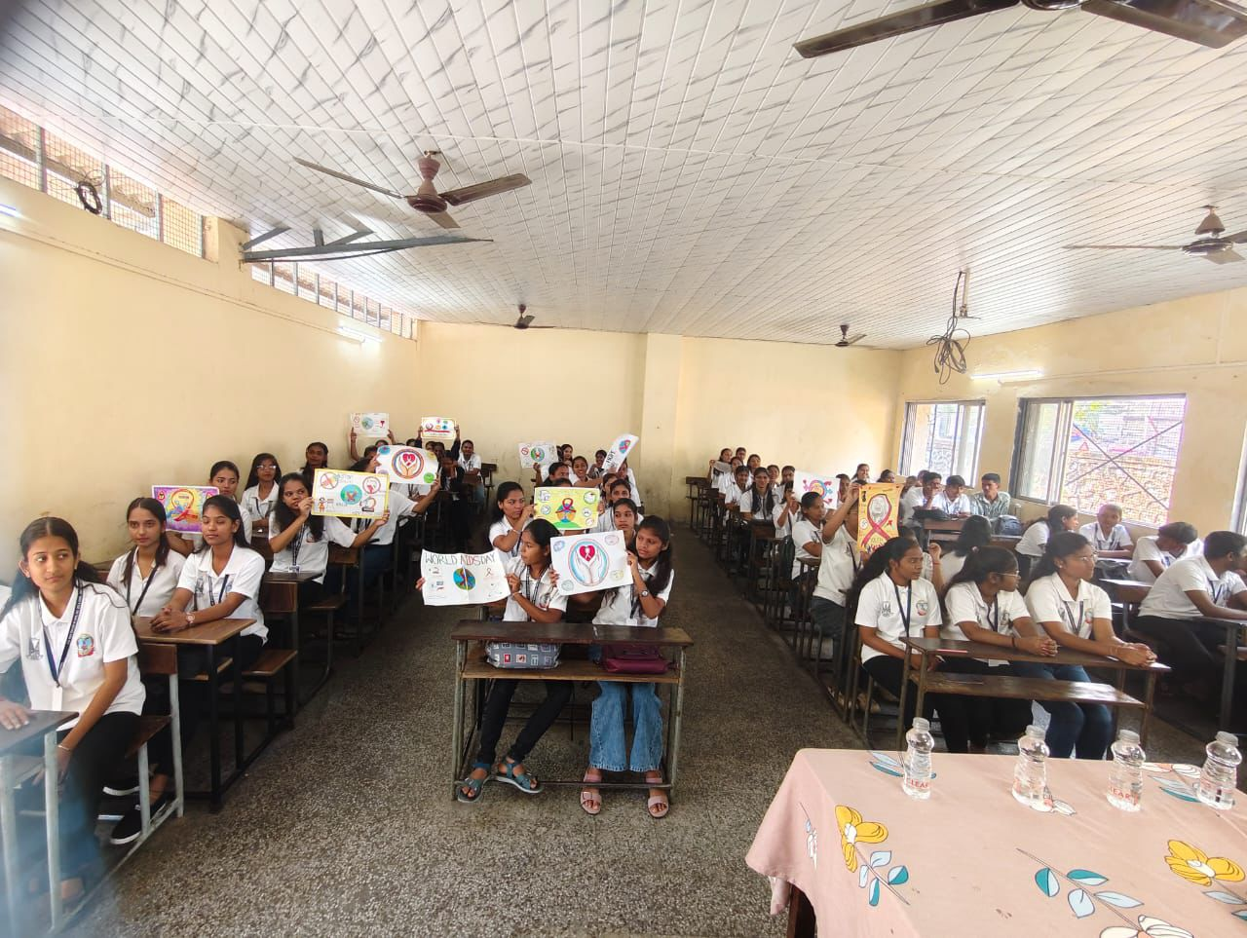

OBJECTIVE OF PROGRAM: To create awareness about HIV/AIDS among students through creative expression and to promote correct information, prevention methods, and social responsibility.
DATE: 01/12/2025
LOCATION: F.G NAIK COLLEGE
PARTICIPATING STAFF: All the NSS volunteers, teaching and the non-teaching staff of the college.
NUMBER OF VOLUNTEERS PARTICIPATING: 24
The NSS Unit organized an HIV/AIDS Poster Making Competition to encourage students to spread awareness through art and creativity. The competition aimed to educate students about the causes, prevention, and social impact of HIV/AIDS while removing myths and stigma associated with the disease.
Students actively participated by creating informative and meaningful posters conveying strong messages about awareness, prevention, and empathy towards people living with HIV/AIDS. The activity helped students understand the importance of awareness and responsible behavior in society.
PROGRAM DETAILS: The program commenced with a brief introduction explaining the theme and objectives of the competition.
The NSS Unit successfully conducted the HIV/AIDS Poster Making Competition, promoting awareness, creativity, and social responsibility among students.

NSS IQAC
PROGRAM OFFICER CO-ORRDINATOR I/C PRINCIPAL

